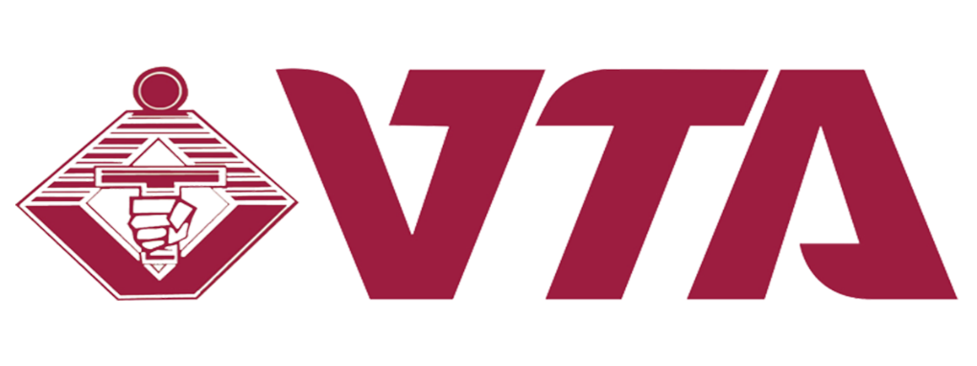
Vocational Training Authority OF Sri Lanka

Green Thread Fashion Brand
Brand Report
Graphic Project 2025
Submitted by: M.P.L Liyanage

Supervised by: MR.Nishantha

Table of Contents

Executive Summary / Abstract 3
Introduction 4
Research and Analysis 5
Concept Development 6
Design Process 7
Final Designs 8
Feedback and Revisions 15
Outcome and Evalutaion 16
Project Management Table 16
Budget simulation 17
Conclusion 18
References 18
Appendices 18

1. Executive Summary / Abstract

- This project develops a comprehensive visual identity and marketing material for Green Thread, an eco-friendly fashion brand focusing on sustainable clothing. The design process involved market research, concept ideation, mood board creation, and final outputs including:
- A Facebook post design
- An A2 promotional poster
- A tag design
- A tote bag design
- A mood board
- A style guide
- A project management sheet
- The designs embody the brand’s values of sustainability, minimalism, and modern eco-conscious aesthetics.

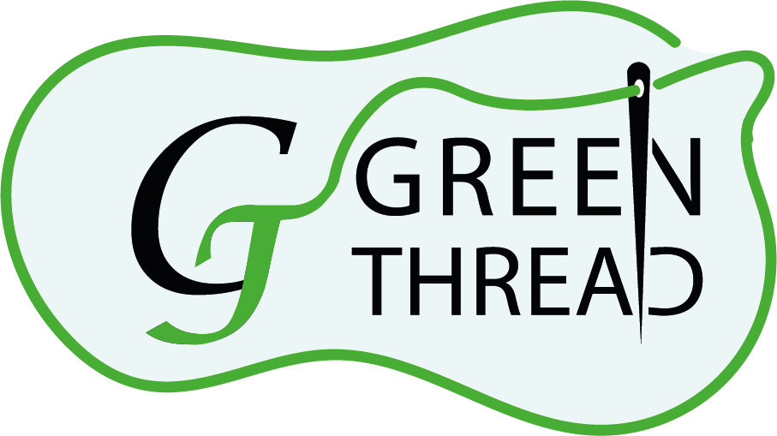

2. Introduction

- Green Thread is a sustainable fashion that emphasizes eco-friendly fabrics and ethical production.

Purpose & Objectives:
- To create a consistent and appealing brand identity.
- To develop marketing materials that engage eco-conscious consumers.
- To establish guidelines for future branding and promotions.

Target Audience:
- Young adults (18–35) interested in sustainable fashion, eco-friendly lifestyles, and modern minimal design.

Scope:
- Deliverables include digital and print promotional designs, branding elements, and supporting materials.

3. Research and Analysis
- Industry Trends: Growing consumer demand for sustainability in fashion.

Competitor Analysis:
- Brands like Patagonia, Ever lane, and Eco love emphasize minimal, earthy tones with strong eco-messaging.

Audience Insights:
- The target market values authenticity, environmental responsibility, and stylish yet simple design.

Mood Board:
- Includes natural textures (linen, cotton), earthy green and beige tones, modern sans-serif typography.

Typography & Colour Theory:
- Fonts: Clean, sans-serif, calligraphy italic (Montserrat / Poppins).

- Palette: Variants of green colour

4. Concept Development
- Ideas: Sustainability, modern minimalism, organic textures.

- Sketches:
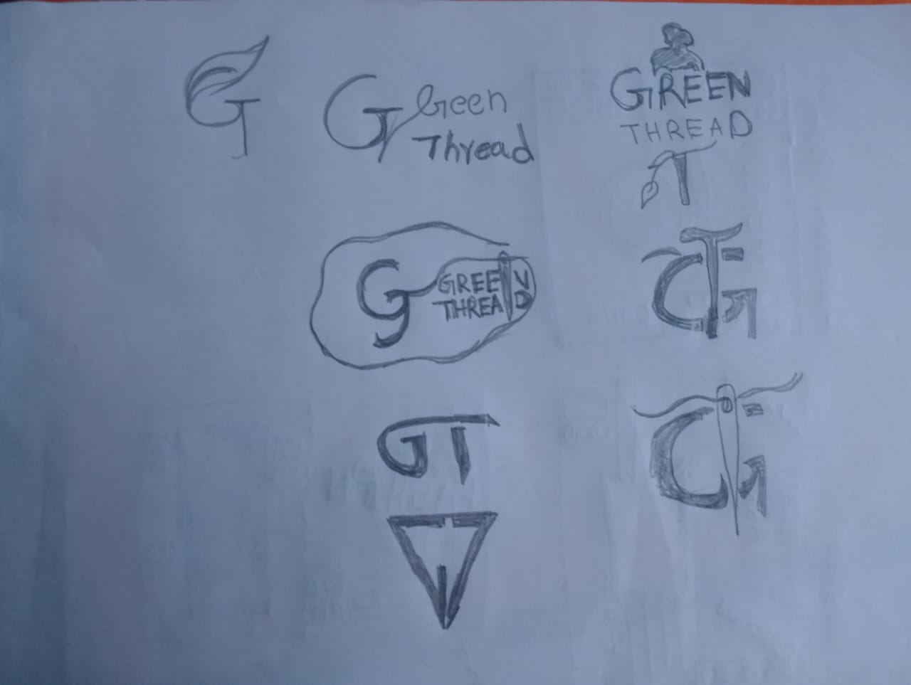

- Design Rationale: A clean, modern look that communicates eco-friendliness while appealing to fashion-conscious audiences.

- Theme Selection: “Sustainable Style, Naturally.”

5. Design Process
- Tools Used: Adobe Illustrator, Photoshop for mock-ups, Post and Poster designing.

- Steps:
- Created logo refinements and tag mock-ups.
- Built mood board for tone consistency.
- Designed poster and Facebook ad with bold typography and nature-inspired imagery.
- Developed tote bag design featuring Brand Logo

- Colours: Used green theme colours for designs.

- Challenges:
  - Balancing trendy fashion aesthetics with sustainability themes.
  - Resolved through simplified layouts and organic textures.

6. Final Designs
Style Guide
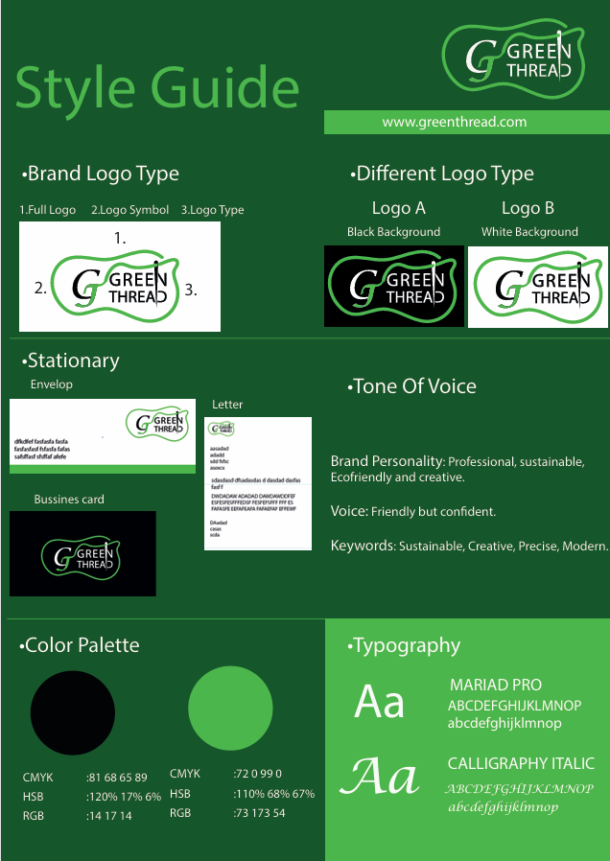

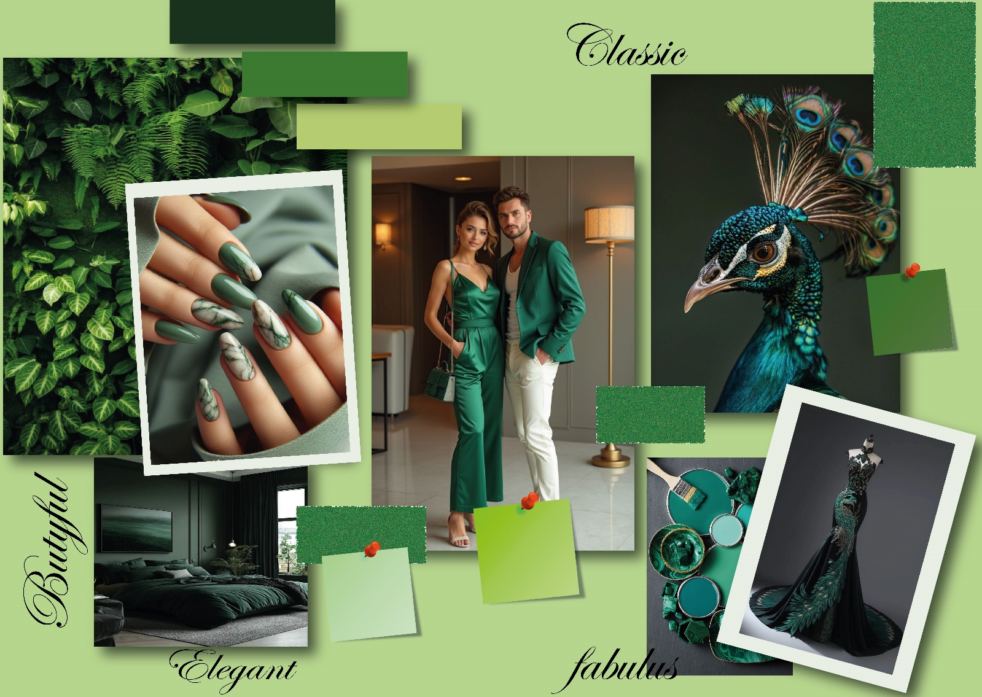
Mood Board

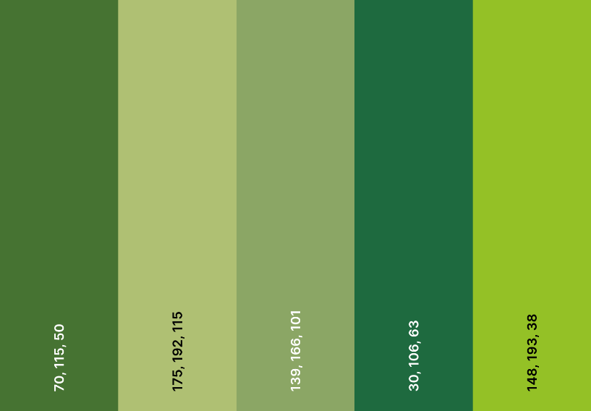
Typography
Edwardian Script ITC
Aa
Used colours

Facebook/Instagram post:
1.

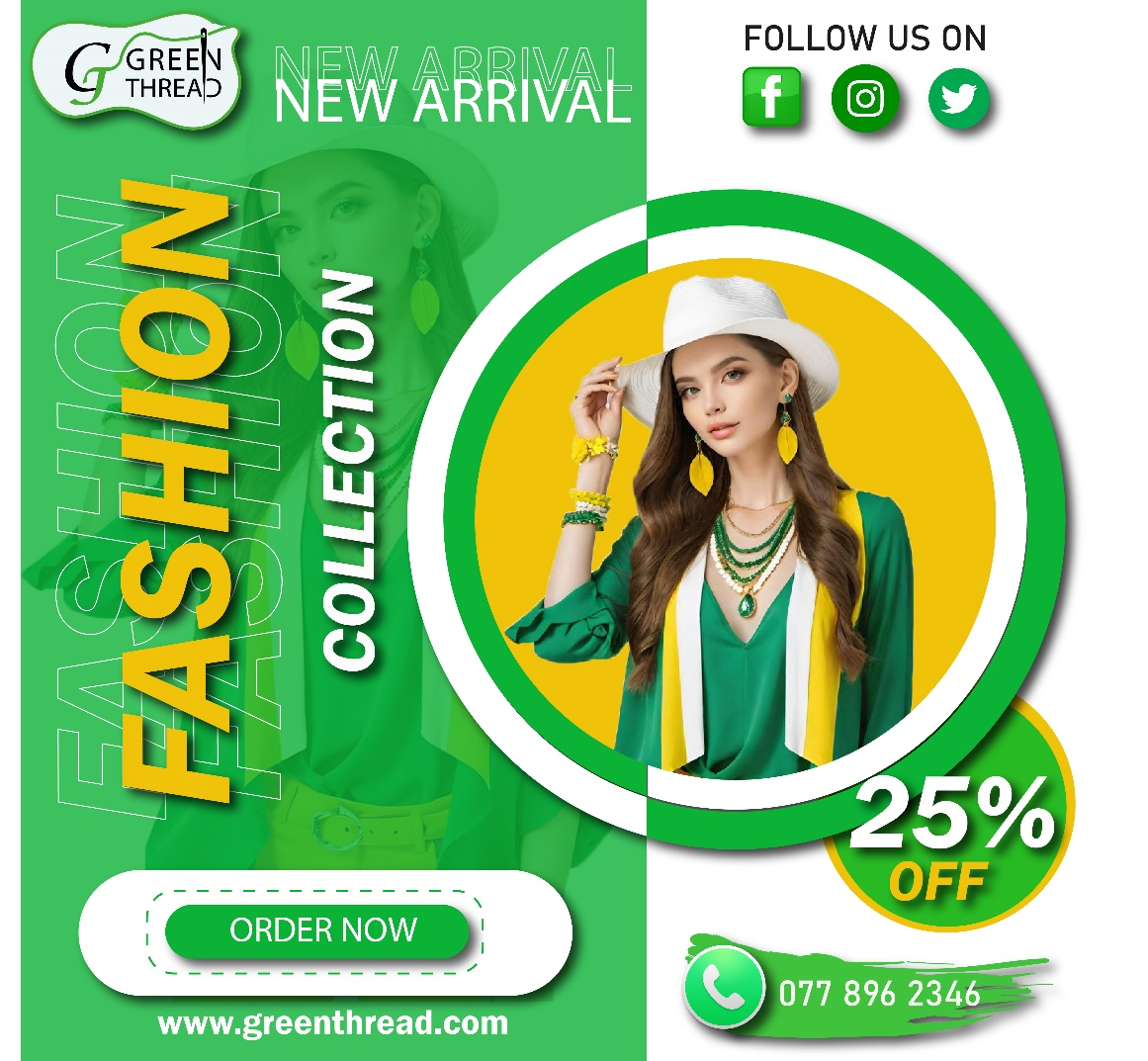
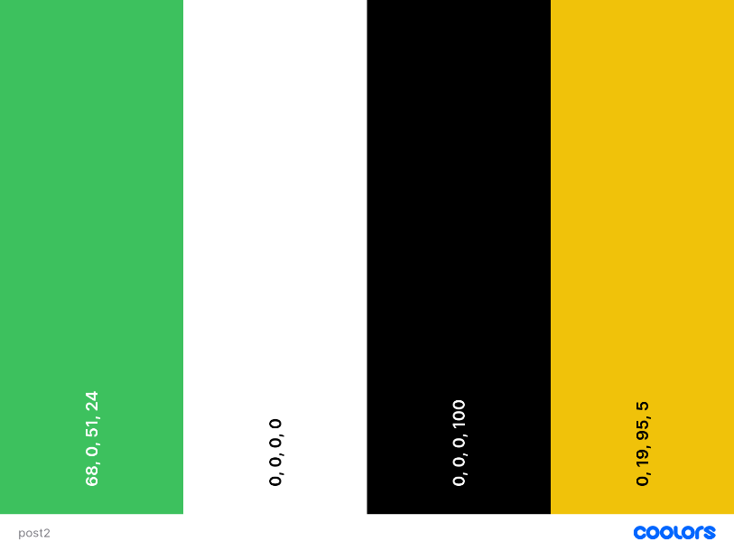
Used colours
Typography
Myriad Pro
Aa
Franklin Gothic Demi
Aa

2.
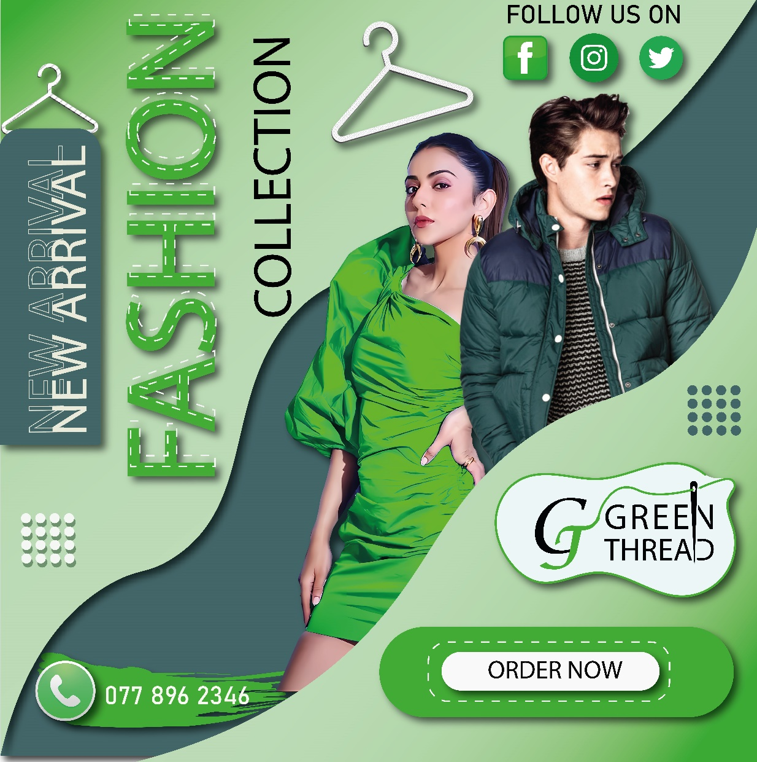
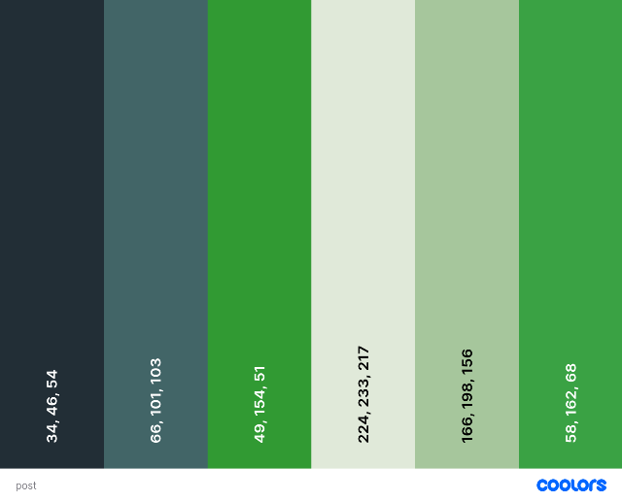
Typography
Used colours
Myriad Pro
Aa
A2 Poster:
1.
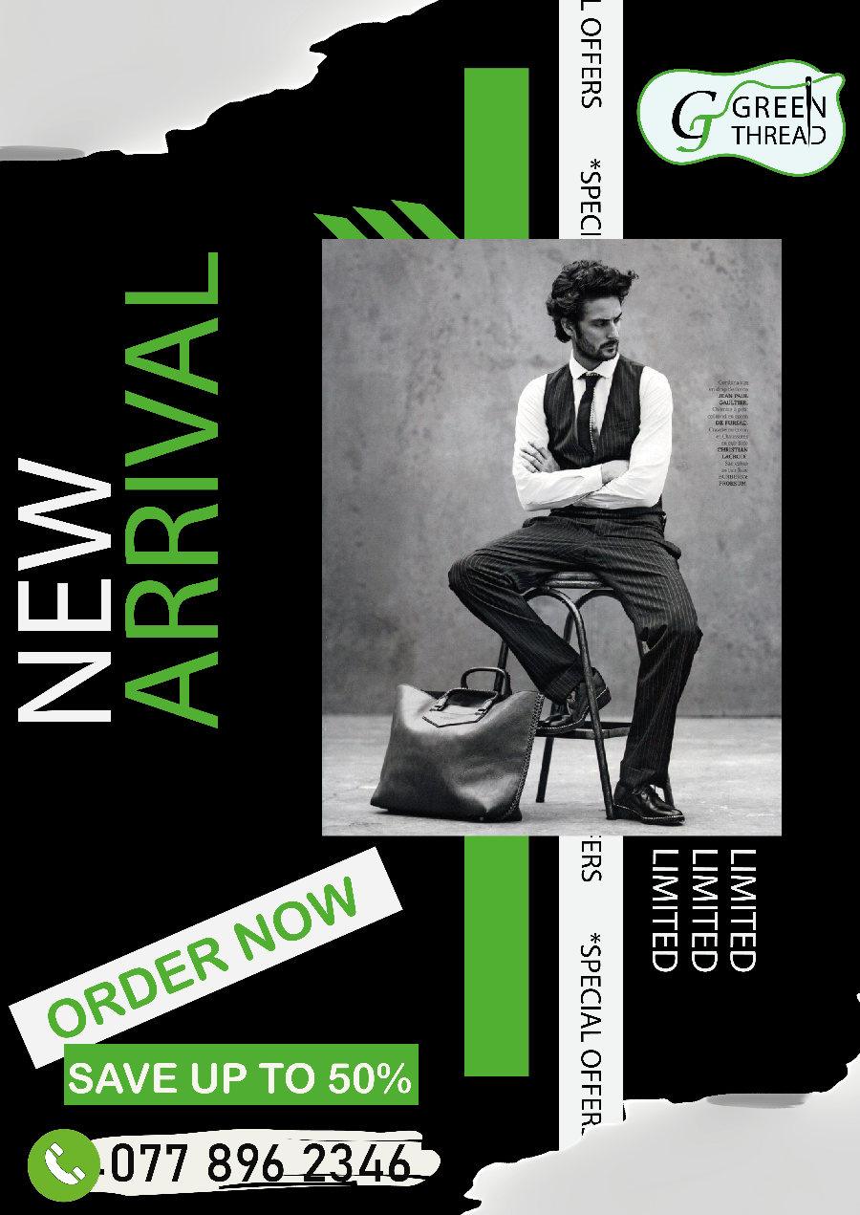

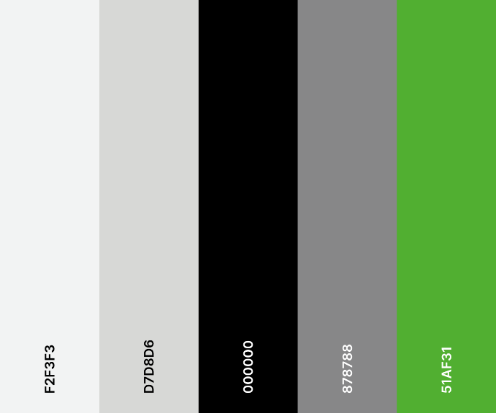
Arial Rounded MT Bold
Aa
Myriad Pro
Aa

Typography
Used colours
2.
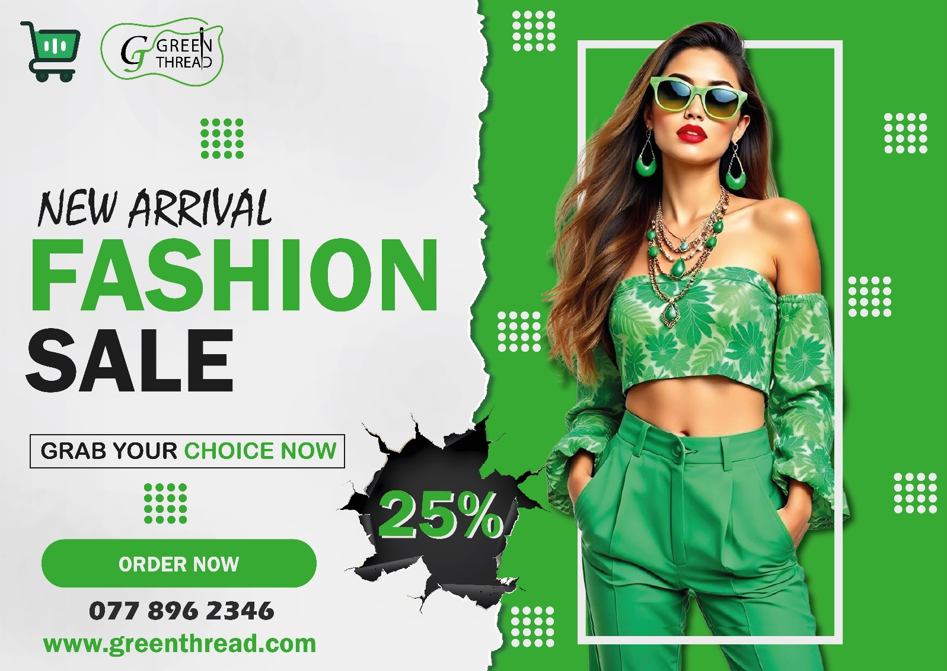

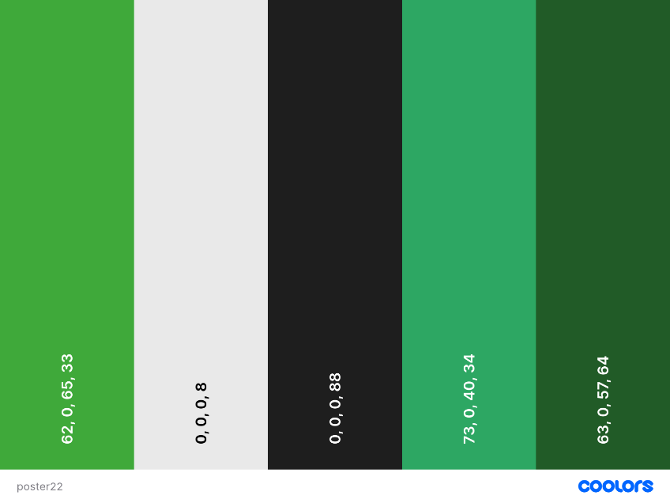
Used colours
Typography

Mistral
Aa
Franklin Gothic Demi
Aa

Brand Tag:
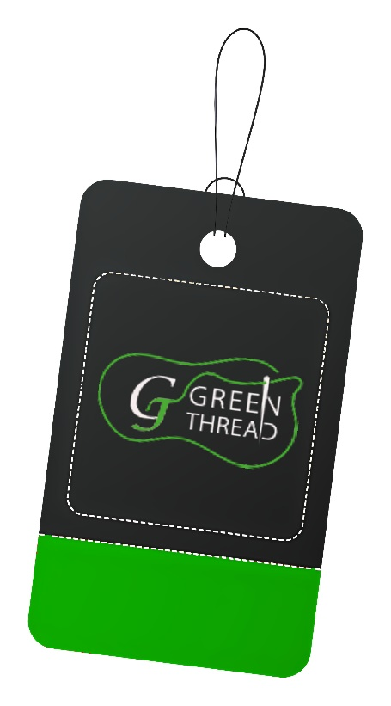
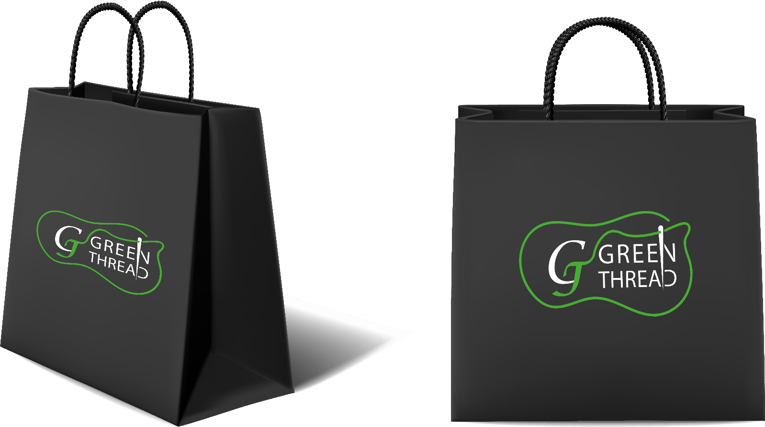
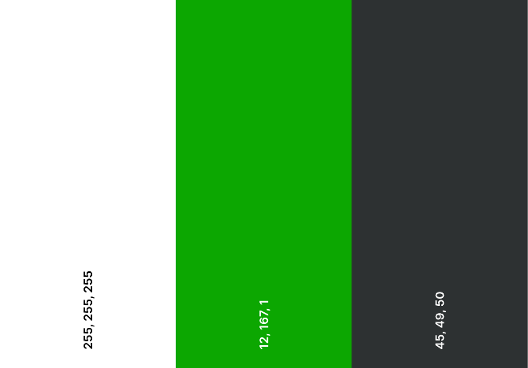
Brand Tot Bag:

Used Colours

7. Feedback and Revisions

- Feedback from peers, clients, or supervisors

- Nice and very attractive poster and Post.
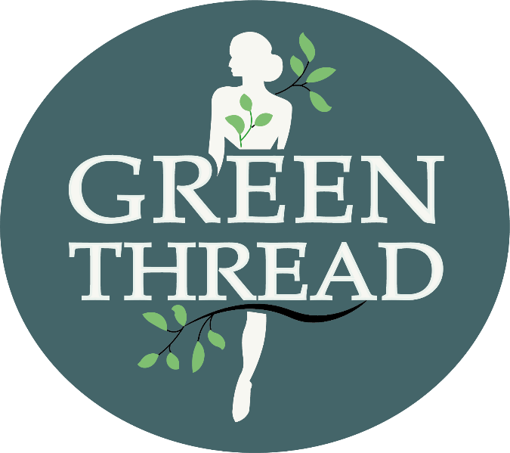
- Logo need to be more simple.
After
Before

8. Outcome and Evaluation

- Designs met objectives by creating a consistent, sustainable visual identity.
- Audience testing showed high appeal among eco-conscious individuals.

- Lesson learned: clarity and minimalism strengthen brand communication.
- Improvement area: expand identity into packaging and e-commerce platforms.

9.Management Table
Task | Responsible | Days | Deadline | Status
Brand concept Development | Designer | 1st day | 1weak | Done
Logo creation | Designer | 2nd day | 1weak | Done
Mood board creation | Designer | 2nd day | 1weak | Done
Style guide development | Designer | 3rd day | 1weak | Done
Fb post Design | Designer | 4th day | 1weak | Done
A2 post design | Designer | 5th day | 1weak | Done
Tag Design | Designer | 6th day | 1weak | Done
Tote Bag Design | Designer | 6th day | 1weak | Done
Final project Report | Designer | 7th day | 1weak | Done

10.Budget Simulation
Deliverable/Task | Hours | Cost per hour | Total cost
Brand concept Development | 3hours | Rs.200 | Rs.600
Logo creation | 5hours | Rs.200 | Rs.1000
Mood board creation | 3hours | Rs.200 | Rs.600
Style guide development | 2hours | Rs.200 | Rs.400
Fb post Design | 3hours | Rs.200 | Rs.600
A2 post design | 4hours | Rs.200 | Rs.800
Tag Design | 30min | Rs.200 | Rs.100
Tote Bag Design | 30min | Rs.200 | Rs.100
Final project Report | 3hours | Rs.200 | Rs.600
Software Cost

Total cost: Rs.4800

Software/application used | Hours | Cost per hour | Total cost
Adobe illustrator | 8hours | Rs.100 | Rs.800
Adobe Photoshop | 5hours | Rs.100 | Rs.500
MS word | 3hours | Rs.50 | Rs.150
Total cost: Rs.1450
Total Budget: Rs.6250

11. Conclusion
The Green Thread project successfully established a cohesive visual identity aligned with sustainability and fashion-forward aesthetics. Future work could expand into digital campaigns, e-commerce design, and packaging innovation.

12. References
https://www.pinterest.com/
https://www.cleanpng.com/
https://www.google.com/

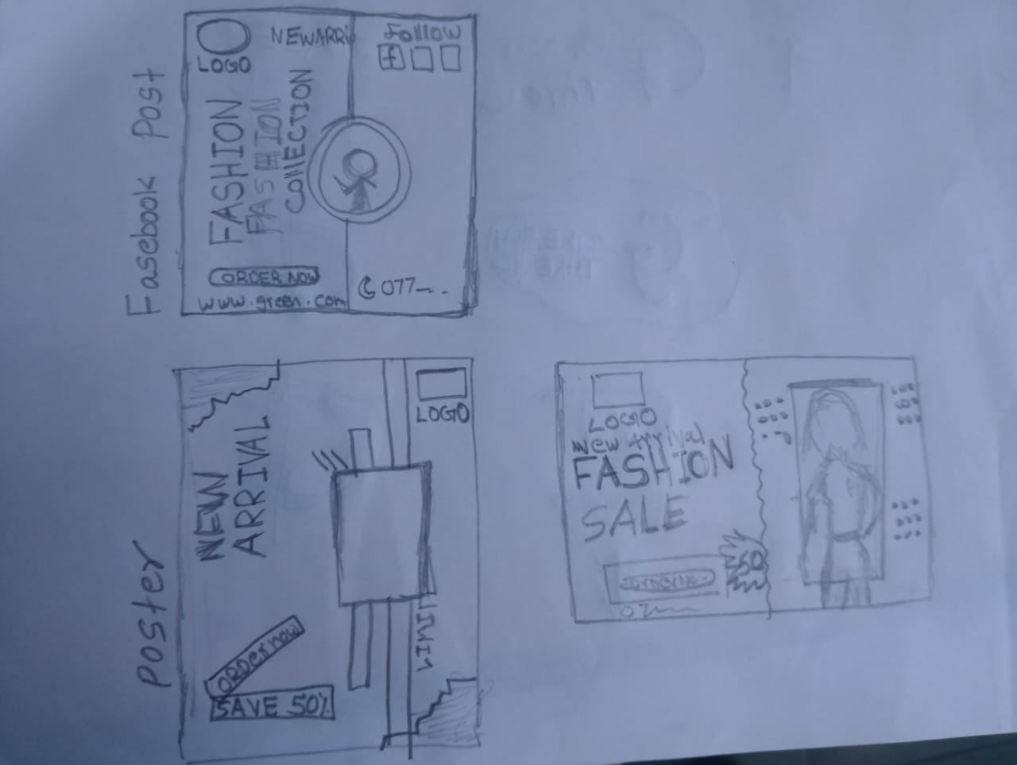
13. Appendices

